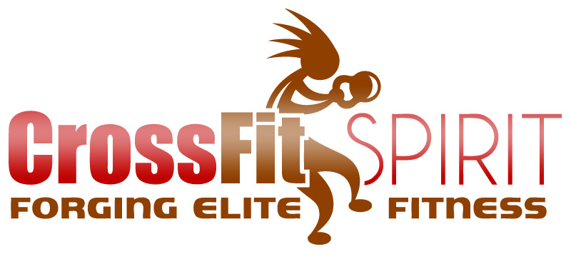
PRESS RELEASE

July 12, 2010

Hinckley, OH – July 12, 2010 – CrossFit Spirit today announced their new fitness center located at 2577 Center Rd. at the Hinckley Corp. Park.

Getting in shape just got a whole lot more fun and effective for residents of Medina County. Stress, time constraints and the ready availability of unhealthy food leave many Americans frustrated in their desire to lead fit, healthy lives.

“CrossFit is a fitness trend sweeping the country with amazing results for those who embrace it” says owner/coach Hank Kelm. The CrossFit method incorporates full body functional movements using varying elements of gymnastics, olympic weightlifting, running and rowing. “The great thing about CrossFit is that the workouts are short and scalable for everyone from athletes and firefighters to soccer moms and retirees” says Kelm, “and, every workout is pre-planned and coached by a certified CrossFit trainer. It’s like getting personal training for a fraction of the cost.” Co-Owner and Coach Melanie Kelm adds “CrossFit also promotes healthy eating plans that really drive results. There’s no starvation dieting, just back to basics with food choices that your great-grandmother would recognize and approve of.” Whether your goals are weight loss, improved athletic performance or just a fun way to get in shape, CrossFit will get you results like no other fitness program.

More information is available at www.crossfitspirit.com or by calling 330-242-2584. CrossFit Spirit offers group classes, CrossFit Kids classes and Teen Athlete Strength and Conditioning Camps. Email: Melanie@crossfitspirit.com. Facebook: “CrossFit Spirit”

Contact information:
Hank Kelm
CrossFit Spirit, Caveman Fitness ltd.
2577 Center Rd.
Hinckley, OH 44233

440-289-0455

